Probabilistic Robotics on the NXT
David AuBuchon, Roger Glassey
June 15, 2009 revised Oct 26 2013
Objective:

Improve the accuracy of NXT navigation in a plane, using probabilistic robotics. All the quantities used in calculating the robot pose are random variables because they are ultimately based in sensor data and therefore contain random noise. Furthermore, the commands to rotate and travel are not carried out exactly.
Method:

The PlaneNavigator class uses two classes for estimating current pose (its planar coordinate plane and its heading) as it navigates in a hallway.: It controls a robot with two independently controlled wheels which can travel accurately in a straight line and can rotate in place to a new heading.

- The PoseProvider class
This class updates its dead reckoning pose estimate as it rotates to a new way point and then travels in a straight line to get there. At each waypoint, it calls the Locator to compute an estimate of the robot pose. It then calculates the optimal combination of the dead reckoning estimate and the Locator estimate to yield the best estimate of its current pose and each component of the pose.
- The Locator class
This class is a software abstraction of a light sensor and ultrasonic sensor mounted on a vertical axel about 6 cm forward of the center of rotation of the robot.. The locator calculates its pose by measuring the relative bearing of two light beacons in known locations, and measuring the distance to a wall of the hallway. The origin of the coordinate system is taken as the location of one of the light beacons.

By determining the variances of these estimates, a closed form expression can be used to calculate a new estimate of pose, using the minimum variance convex combination of the two estimates.

Experiments:

Two experiments were run, in order to determine the variance of the estimates provided by the Plane Navigator dead reckoning and the Locator respectively. It was assumed that the estimates are unbiased.

In one experiment, the Plane Navigator was run up and down the hall (along the x-axis), rotating 180 degrees at each end of an 8 foot stretch. At the end of the experiment, cumulative error in x-axis position, and cumulative error in heading was measured. This data provided an estimate of variance of error distance traveled in inches and the error of the rotation angle in degrees.

In the other experiment, the Locator was set in several locations, at varying distances from the y-axis. At each distance, a number of position estimates was recorded using the Locator and the Datalogger. This data was used to determine the variance of the error in x estimate (as a function of x), y estimate, and heading estimate as provided by the Locator.

Variance Results:

The experiments resulted in the following measurements of variance(angles in degrees, distance in inches):

- Dead reckoning r travel distance variance: 0.25
- Dead reckoning turn variance: 4
- Locator X variance: 0.008 * X²
- Locator Y variance: 0.25
- Locator H variance: 1

Dead Reckoning Estimated Position Variance Calculations:

Recall that if a random variable Z is the sum of two uncorrelated random variables X and Y, V(Z) = V(X) + V(Y)
and if Z = a X, then V(Z) = a² V(X).

In the following discussion, all the quantities used in calculations are random variables. We assume that the variance of all the sources of error are known, and we use these can calculate the variance of each component of the estimated pose.
That is, the variance of the estimated travel distance and heading must be translated into the variance in resultant x and y:

Initial pose h₀, y₀, h₀ with variance V(h₀ ), V(y₀), V(h₀ )

Movement: robot rotates through random angle a, to new heading, whose estimated value is

1. h₁ = h₀ + a;
2. Var(h₁) = Var(h₀) +Var(a)

Then travels a random distance d. The estimated movement vector

3. (∆x, ∆y ) = d cos(h₁), d sin(h₁)

These random variables are products of random variables. If a random variable Z is the product of two random uncorrelated variables X and Y, with mean E(X), E(Y) and variance V(X) and V(Y)

4. V(Z) = E²(X) V(Y) + E² (Y) V(X) + V(X) V(Y)
Hence
5 V(∆x) = E²(d)V(cos(h₁)) + E²(cos(h₁)V(d) +V(cos(h₁)) V(d)
We will approximate the variance of the non-linear functions of the random variable h₁ by using a first order Taylor series as a linear approximation, giving

6. V(cos(h₁)) = sin²(h₁) V(h₁) and V(sin(h₁) = cos²(h₁) V(h₁)

Substitute (6) into (5)

7. V(∆x) = d² sin²(h₁)² V(h₁ ) + cos²(h₁) V(d) + V(d) sin²(h₁) V(h₁)

Likewise,

8. V(∆y) = d² cos²(h₁)² V(h ) +sin²(h₁) V(d) + V(d) cos²(h₁) V(h₁)

Define the pose after the move as::

9. x₁ = x₀ + ∆x and
10... y₁ = y₀ + ∆y
11. V(x₁) = V(x₀) + V(∆x)
12. V(y₁) = V(y₀) + V(∆y)
The updated heading after the move is given by eq 1 and e1 2.

Minimum Variance Convex Combination Calculations:
We need to combine the estimated updated pose with the pose as estimated from Locator.. This is an instance of a general problem We have two independent estimates (x and y) of a random variable z. and we seek a minimum variance linear combination of these two. If we are willing to assume that x and y are normally distributed with known variance., the problem has a simple solution. If we take x as the prior estimate, and y as a new information, the resulting estimate is the Bayes posterior as a result of the normal distribution assumption.
Let be the optimal linear combination of x and y.

13. 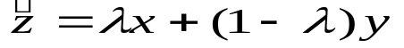

Calculate the variance of from the variance of x and variance of y.
14. 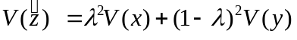
Find the value of λ to minimize the variance of ,
15.
Solve for λ
16. 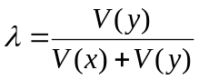
Substitute 16 into 13 and simplify
17. 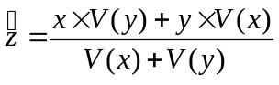
Substitute 17 into 15 and simplify to get the variance of the optimal estimate.
18 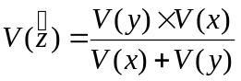
Note that this always less than the variance of the original estimates.
Using the subscript L to denote estimates derived from the Locator, and substituting into 18 we obtain the optimal combined estimate for the components of the pose:

19 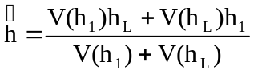
20 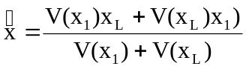
21. 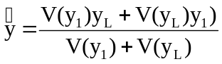

Using 19, the variance of each component of the optimal estimate of pose are:
22 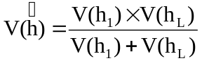
23 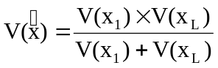
24 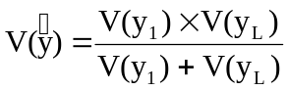

Simulation Results

A series of 20 hypothetical destinations were input into excel. These movements were made to trace out a large rectangle, 16 feet wide by 8 feet tall. The above calculations were implemented for each movement, to observe the evolution of position variance when using the minimum variance convex combination estimate. Here are the results:
Destinations |  | Locator variances |  |  | Weights |  |  | Weighted variances
X | Y | var xL | var yL | var hL | lam X | lam Y | lam H | var X final | var Y final | var H final
-96 | 0 | 0 | 0 | 0 | N/A | N/A | N/A | 0 | 0 | 0
96 | 0 | 7.3728 | 0.25 | 0.000305 | 0.032796 | 0.994465 | 0.8 | 0.241801 | 0.248616 | 0.000244
96 | 96 | 7.3728 | 0.25 | 0.000305 | 0.650417 | 0.666051 | 0.827586 | 4.795394 | 0.166513 | 0.000252
-96 | 96 | 7.3728 | 0.25 | 0.000305 | 0.40629 | 0.995424 | 0.828402 | 2.995498 | 0.248856 | 0.000252
-96 | 0 | 7.3728 | 0.25 | 0.000305 | 0.69182 | 0.666157 | 0.828426 | 5.100652 | 0.166539 | 0.000252
96 | 0 | 7.3728 | 0.25 | 0.000305 | 0.420535 | 0.995424 | 0.828427 | 3.100518 | 0.248856 | 0.000252
96 | 96 | 7.3728 | 0.25 | 0.000305 | 0.693168 | 0.666157 | 0.828427 | 5.11059 | 0.166539 | 0.000252
-96 | 96 | 7.3728 | 0.25 | 0.000305 | 0.420987 | 0.995424 | 0.828427 | 3.103852 | 0.248856 | 0.000252
-96 | 0 | 7.3728 | 0.25 | 0.000305 | 0.693211 | 0.666157 | 0.828427 | 5.110903 | 0.166539 | 0.000252
96 | 0 | 7.3728 | 0.25 | 0.000305 | 0.421001 | 0.995424 | 0.828427 | 3.103957 | 0.248856 | 0.000252
96 | 96 | 7.3728 | 0.25 | 0.000305 | 0.693212 | 0.666157 | 0.828427 | 5.110913 | 0.166539 | 0.000252
-96 | 96 | 7.3728 | 0.25 | 0.000305 | 0.421002 | 0.995424 | 0.828427 | 3.10396 | 0.248856 | 0.000252
-96 | 0 | 7.3728 | 0.25 | 0.000305 | 0.693212 | 0.666157 | 0.828427 | 5.110914 | 0.166539 | 0.000252
96 | 0 | 7.3728 | 0.25 | 0.000305 | 0.421002 | 0.995424 | 0.828427 | 3.10396 | 0.248856 | 0.000252
96 | 96 | 7.3728 | 0.25 | 0.000305 | 0.693212 | 0.666157 | 0.828427 | 5.110914 | 0.166539 | 0.000252
-96 | 96 | 7.3728 | 0.25 | 0.000305 | 0.421002 | 0.995424 | 0.828427 | 3.10396 | 0.248856 | 0.000252
-96 | 0 | 7.3728 | 0.25 | 0.000305 | 0.693212 | 0.666157 | 0.828427 | 5.110914 | 0.166539 | 0.000252
96 | 0 | 7.3728 | 0.25 | 0.000305 | 0.421002 | 0.995424 | 0.828427 | 3.10396 | 0.248856 | 0.000252
96 | 96 | 7.3728 | 0.25 | 0.000305 | 0.693212 | 0.666157 | 0.828427 | 5.110914 | 0.166539 | 0.000252
-96 | 96 | 7.3728 | 0.25 | 0.000305 | 0.421002 | 0.995424 | 0.828427 | 3.10396 | 0.248856 | 0.000252

These variances are in radians. Observe the weighted variances are significantly lower than the previous best measure of Locator variance.

Summary:

Probabilistic robotics can be implemented on the NXT, using a minimum variance convex combination of the position estimates coming from the TachoNavigator and from the Locator. Resulting estimates of the various measures of position have significantly reduced variances.

